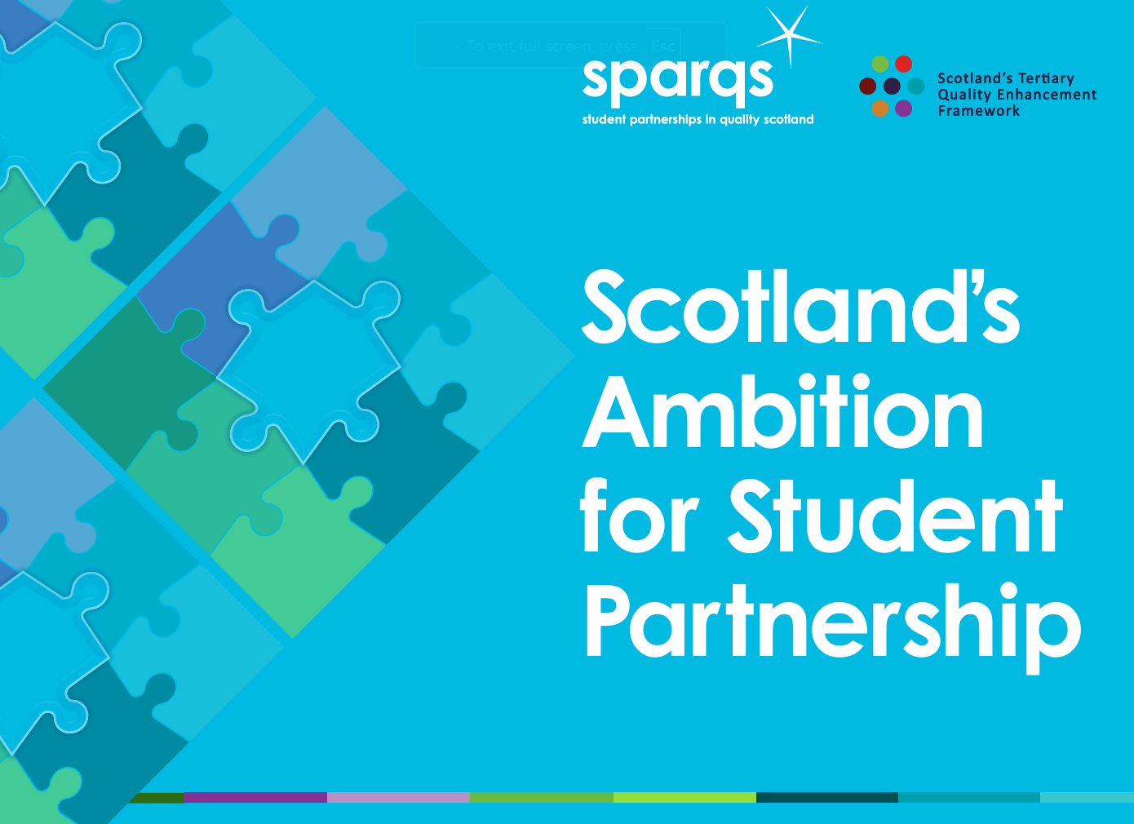
Co-creating an Enhancement Plan for student partnership

(at programme or institutional level) #9

Session Plan

Format
- On campus.
- 90 minute workshop: Standalone.
- 60 minute workshop: If Part 1 undertaken as a pre-session asynchronous activity and the break is excluded.

In advance of session:
- Define scope: Programme or institutional level enhancement planning?
- Plan session accordingly and clearly articulate scope to participants.

Session components
- Part 1: Reflecting on current student partnership practice (individual reflection).
- Part 2: Sharing good practice and identifying enhancement priorities (small group discussion).
- Part 3: Ranking priorities and co-creating an Enhancement Plan (small group activity).

Intended audiences
Collaborative mixed cohorts that offer both staff and student perspectives:
- Student lens: Students’ Association colleagues, Student Officers, Course Reps.
- Staff lens: Programme Leaders, Curriculum Leads, Quality Leads, Directors or Associate Deans for Learning and Teaching.
- Note: members of governing bodies (Court or Board) could be valuable stakeholders to include in sessions focused around institutional-level planning.

Mapping to Professional Standards
Professional Standards for Lecturer’s in Scotland’s Colleges (GTCS):
1.1.2; 1.2.1; 1.3.2/4/5; 2.2.1/5/11/12; 2.5.2/3/6; 3.1.2/4; 3.2.1/2/4; 3.3.2/3; 3.5.2/3
Professional Standards Framework 2023 (PSF 2023) (Advance HE):
V1, V5, K2, K3, K5, A1, A4.

Copyright

Licensed under a Creative Commons Attribution Non-commercial 4.0 licence.
You are free to copy, communicate and adapt the work, so long as you attribute sparqs.

Session outline

Scope of workshop
Enhancement planning at either programme or institutional level (please delete as appropriate).

Intended learning outcomes
By the end of this session participants will be able to:
- Outline Scotland’s Ambition for Student Partnership and reflect on their individual role within it.
- Identify and share examples of good practice in student partnership from their programme/institution.
- Discuss and rank priorities for a co-created Enhancement Plan for student partnership for their programme/institution.
- Co-create initial ideas for an Enhancement Plan for student partnership for their programme/institution.

Small group composition
- 3-4 participants per group, each group containing mixture of staff and students.

Resources required
- Electronic (via QR code) or hard copies of Scotland’s Ambition for Student Partnership – one per person.
- A3 hard copies of the Student Partnership Jigsaw recording diagram - one per person + one extra per group.
- ‘Diamond Nine’ Activity (#13) cards for Scotland’s Ambition for Student Partnership – one pack per group.
- Diamond Nine recording sheet – one per group
- Coloured marker pens (e.g. Sharpie) in two different colours - one colour for students, another colour for staff.

Part 1: Preparation and Reflecting on current student partnership practice
Note: Part 1 could be undertaken by participants as an asynchronous preparatory task in advance of the session.

Individual activity (20 minutes total)

Activity 1a: Preparation (10 mins)
- Familiarise yourself with Scotland’s Ambition for Student Partnership.
  - Start with: ‘Introduction to Scotland’s Ambition for Student Partnership’: – watch screencast or read summary paper.
  - Flick through Scotland’s Ambition for Student Partnership resource, reading the ‘Ambition’ (p2) and ‘Features’ (p3-4) in full.
- Reflect on your own role within Scotland’s Ambition for Student Partnership (p2).

Activity 1b: Identify good practice and your priority area for enhancement (10 mins)
You will need: A copy of the Student Partnership Jigsaw recording diagram
- Work around the Student Partnership Jigsaw diagram identifying and noting down relevant existing examples of good practice in student partnership for each Feature (jigsaw piece) from your programme/institution.
  - Repeat this for as many Features and examples of good practice as you can.
- Pause, reflect and consider any gaps on your Student Partnership Jigsaw.
- Identify one Feature (jigsaw piece) that represents your top priority for an Enhancement Plan for student partnership in your programme/institution.
- Note: Be ready to share your Student Partnership Jigsaw diagram, and to discuss your examples and priority feature in small groups.

Part 2: Sharing good practice and identifying enhancement priorities

Small group activity (20 minutes)

Activity 2a: Sharing good practice (15 mins)
You will need:
- For reference - your individual Student Partnership Jigsaw diagrams (from Activity 1b).
- A new copy of the Student Partnership Jigsaw recording diagram for your group.
- Marker pens in two different colours.
Small group composition:
- 3-4 participants per group, each group containing mixture of staff and students.

Individually
- Select the appropriate colour pen (one colour for all student group members, and a different colour for all staff group members).
- Add a tick (√) to the relevant Feature on your group’s Student Partnership Jigsaw for every example of good practice that you identified during Activity 1b.
As a group
- Review your group’s Student Partnership Jigsaw and discuss the pattern of distribution of ticks (good practice).
  - Which Features had the most ticks?
  - Which Features had fewest (or no) ticks?
  - Were there any differences between students and staff? Why might this be?
- Work around each Feature, inviting group members to share and discuss one example of good practice that they identified during Activity 1b.
- Capture each example of good practice on your group’s Student Partnership Jigsaw recording diagram.

Activity 2b: Identify individual priorities for an Enhancement Plan (5 mins)
- Without further discussion, invite each group member to individually circle the Feature (jigsaw piece) that represents their individual top priority for an Enhancement Plan for student partnership in your programme/ institution.
- Which Features blocks had the most circles?
- Were there any differences between students and staff? Why might this be?

Break (10 mins)
We suggest including a 10 minute break here if combining Parts 1, 2 and 3 of the session.

Part 3: Ranking priorities and co-creating an Enhancement Plan

Small group and plenary activity (40 minutes)

Activity 3a: Small group - Ranking enhancement priorities (15 mins)
You will need:
- Your group’s Student Partnership Jigsaw diagram.
- A pack of ‘Diamond Nine’ Activity (#13) cards for Scotland’s Ambition for Student Partnership and a Diamond Nine recording sheet.

As a group
In your small group, you will rank your priorities for the enhancement of student partnership in your programme/institution using a Diamond 9 Activity.
- Ensure that everyone’s voice is heard. We suggest inviting student members of your group to share their thoughts first.
- Nominate the following roles and tasks:
    - Timekeeper: keeps the group to time.
    - Scribe: writes down key discussion points during the activity.
    - Spokesperson: feeds back verbally to wider group at end of session.
- Discuss, negotiate, rank and arrange your 9 cards into the ‘Diamond 9’ shape shown below. Ensure that your ‘Scribe’ captures key discussion points on your recording sheet as you do this.
- The blank card is intentional, your group can add your own category to this if you wish to.

Card
Card
Card
Card
Card
Card
Card
Card
Card
Most important
Least important

Activity 3b: Small group – Initial enhancement planning (10 mins)
As a group
- Select the top-ranked Feature from your Diamond 9 activity.
- Brainstorm initial ideas for a draft Enhancement Plan for this Feature.

Activity 3c: Plenary – Share group outputs (10 mins)
In plenary
- Invite each group to share:
  - Their priority area for enhancement (from Activity 3a) with other groups.
  - One example from their draft Enhancement Plan (from Activity 3b) with other groups.

Activity 3d: Plenary - Summary and close: (5 mins)
In plenary
- Summarise key messages and outputs from the session and agree next steps for Enhancement Planning

